EXPERIMENT 3: SEQUENTIAL CIRCIUT ANALYSIS
Objectives:
Understanding synchronous sequential circuit analysis, Moore and Mealy machines, time diagrams, hazardous and non- hazardous faulty outputs, IC optimization.
Introduction:
The aim of logic design is to minimize number of memory elements and minimal-input-span gates. At realization level we have to use commercially available SSI elements. Normally, there exists two memory elements or four two-input-gates within each commercially available SSI. Therefore SSIC minimizations are required as well as memory and gate minimization. The following logic circuits given in Figure 1 and Figure 2 are equivalent. The first one requires total six SSI components: one for D FF, one for JK FF, one for EXOR, one for AND and one for OR gates. The second one requires only three SSI components: one for JK FFs, and two for NAND gates. This means three SSI components will be adequate instead of six.
Preliminary Work:
Find state diagram for the logic circuit given in Figure 2. Simulate this circuit on Proteus for the inputs given in report page and also for the verification of the state diagram you found.
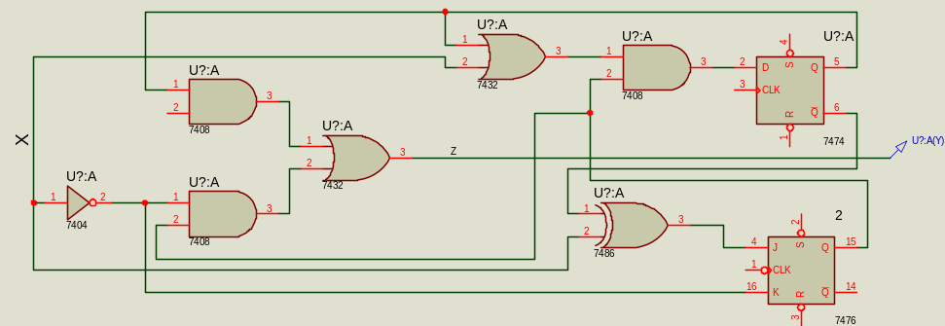
Figure 1
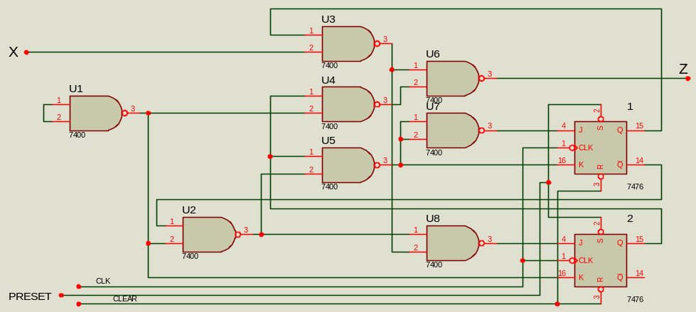
Figure 2
Procedure:
- Realize the circuit given in Figure 2 on the breadboard.
- 7476 and 7408 data sheets are available in course WEB page.
- Do not forget power and ground connections.
- Use standard switches (TTL SWT) for R, S control inputs to as required.
- Use negative pulsar switch for clock input.
- Use LED s for states and z output observation.
- Complete the following time diagrams if Q₁Q₂ states and z output for the initial states 00 and 11.
Required Components: One 7476 JK FF IC, and two 7400 NAND IC’s.

EXPERIMENT 3 REPORT: A SEQUENTIAL CIRCIUT ANALYSIS

Date: Session: Group
Name: Name: Name:
Surname: Surname: Surname:

Questions
- Explain why circuits given in figures 1 and 2 are equivalent.
- How many different output sequences can we observe for the same given input sequence? Why?
- Why do we observe faulty outputs in this circuit? Why?
- Which time interval could we observe faulty outputs? Why?
- In order to see non- hazardous faulty outputs only, what would you do? Why?(Hint: additional FF)
- Find an initial state and input sequence which gives a hazardous faulty (0) output. Repeat this case for hazardous faulty (1).

Initial state: 00

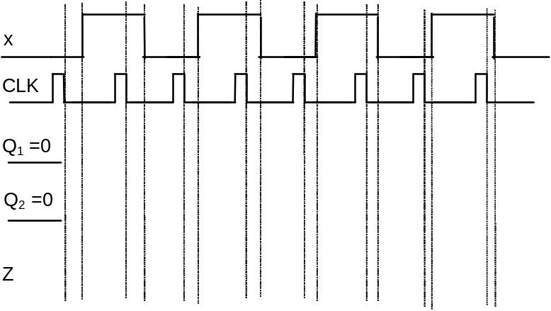

Initial state: 11
